Carbon Cycling:
Environmental Processes that Change Our World

High School

STUDENT PAGES

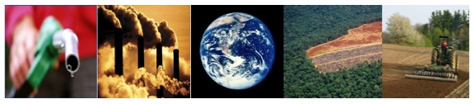

Lindsey Mohan, Jonathon Schramm, Hui Jin, Li Zhan, & Andy Anderson
Environmental Literacy Project
Michigan State University
November 2009
Name:____________________________________________Period/Hour:________

Carbon Movements

With your group, please fill out the following process tools to the rest of your ability.
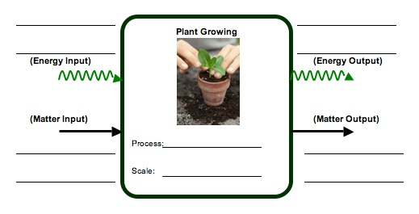
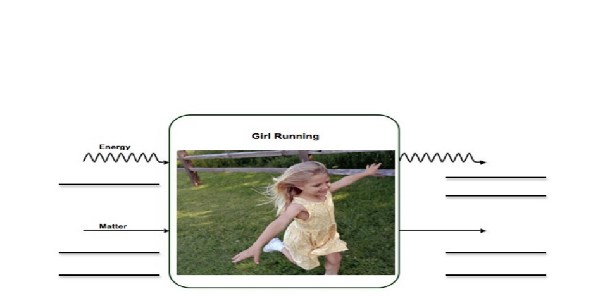
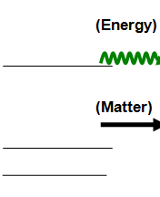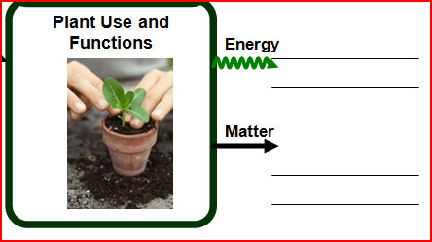

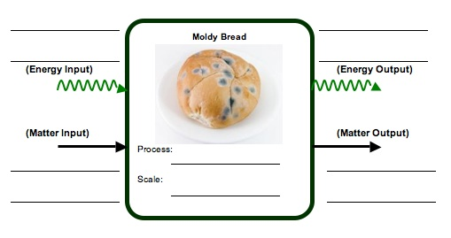
Questions

1) What similarities do you see between the events above in terms of emitting carbon?

__________________________________________________________________________________________________________________________________________________________________________________________________________________
How about in terms of taking up carbon?
______________________________________________________________________
____________________________________________________________________________________________________________________________________________

2) What are the main forms in which carbon occurs in the environment, based on your process tool discussion?

__________________________________________________________________________________________________________________________________________________________________________________________________________________
Name:____________________________________________Period/Hour:________

The Carbon Cycle
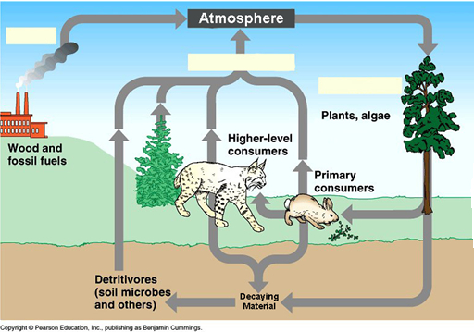
The diagram above shows parts of the global carbon cycle. In general, carbon in the earth’s systems is classified as either organic or inorganic, depending on whether it is in living or once-living materials (organic) or not (inorganic). Locations where carbon can be found are termed pools, and the processes that move carbon from one pool to another are called fluxes. Using the diagram, think of some specific pools where you might find organic and inorganic carbon molecules, as well as the types of molecules in which carbon might be found in those pools. Don’t worry as much about specific molecular names, unless you know some; instead try to identify categories of molecules. An example is provided. Complete the table below.

Organic Carbon |  | Inorganic Carbon
Plants | Molecule Types  Starch, Sugar |  | Molecule Types

Now fill in the three blank flux boxes with the process that would be responsible for moving carbon through each flux. Why does the middle flux have so many pools it moves carbon from?
____________________________________________________________________________________________________________________________________________________________________________________________________________________________________
Name: ________________________________________ Date: _____________

What Do Food Chains Tell Us?

The food chain shows that a caterpillar consumes spicebush, and a thrush eats the caterpillar. What do the arrows tell us about the matter and energy that moves between the organisms?
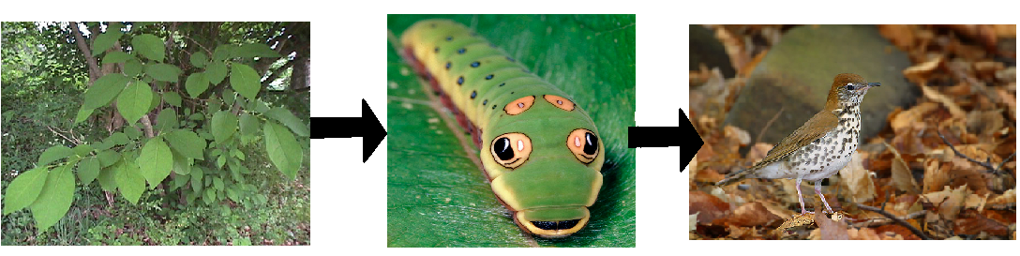

Practice: First, think about the shrub. How does the shrub transform matter and energy? Use the process tool to show how spicebush makes its food.

Spicebush Growing

Energy
Energy

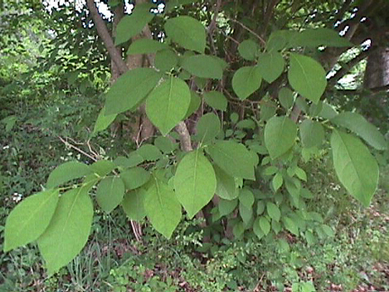

Matter
Matter

Spicebush will use some of the food it makes to keep its cells functioning, and when it uses this food, it gives off gases into the air. But a lot of the materials in plants may stay stored in their body structures, like blades of grass, or branches on trees. This stored material is what becomes food for the caterpillar in the food chain. On the next page, show how matter and energy change when the caterpillar eats the spicebush.
Remember there are two things that can happen to food when the caterpillar eats it. The food can be used for growth or the food can be used for movement.
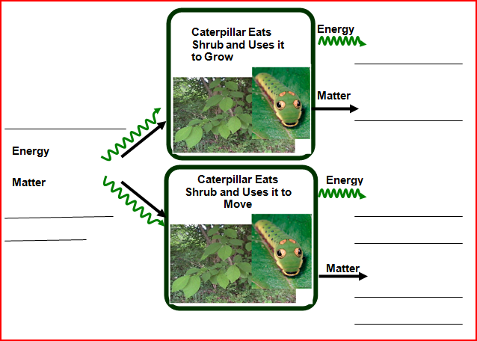

The food the caterpillar eats and uses to move will become part of the air in the atmosphere, so the thrush is not able to have those materials. When the thrush eats the caterpillar, it only gets the materials the caterpillar stored in its body to grow. On the next page, use the process tool to show what happens to matter and energy when the thrush eats the caterpillar.

Remember there are two things that can happen to food when the thrush eats it. The food can be used for growth or the food can be used for movement.

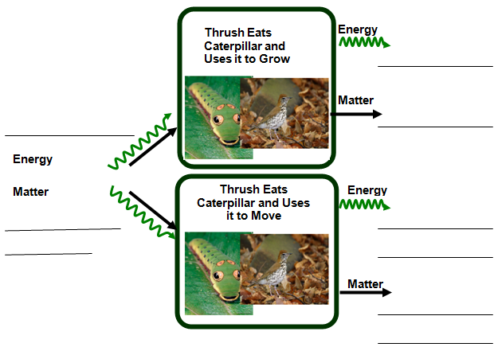

Blank

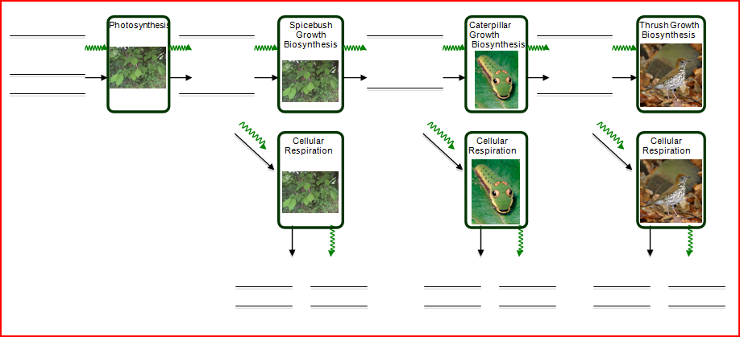

Name: _____________________________________ Date: ______________

Island Ecosystem

In the middle of the Pacific Ocean, there is a small island. Imagine that only two types of animals live on the island: giraffes and lions. There are also trees and grass on the island. The island is an example of an ecosystem. Assume it is not disturbed by human beings. The ecosystem on the island is a sustainable ecosystem, which means that the population of each type of organism does not change drastically over time.

You will use pictures and coins to build a model of the ecosystem.


The pictures of organisms represent the number of organisms in the ecosystem. The picture can also represent the amount of matter stored in that type of organism.

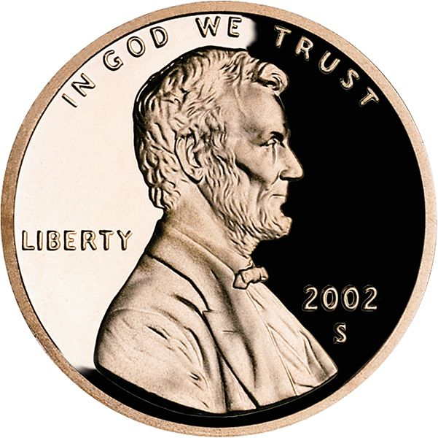
The pennies represent the amount of energy each organism has.

One penny represents the amount of energy each organism stores in its body by growth (this is chemical energy stored in the organism’s body).

Two pennies represent the amount of energy each organism uses for their bodily functions and movement. This energy eventually
turns into motion or heat, and cannot be used by other organisms.

To Build Your Model:

Step 1: Start with Level 1: The Plants. Place 9 trees at the bottom of your model. Place 3 pennies by each tree. Each tree uses 2 pennies and turns these into energy that cannot be used by other organisms (mainly heat). Take 2 pennies away from each plant. Move the remaining pennies to the 2nd level. Based on the number of pennies, how many giraffes can be at this level to have enough energy for survival?

Step 2: Place the appropriate number of giraffes at level 2. Repeat step 1 in order to figure out the number of lions at the third level.

How many trees do you have at level 1? How many giraffes do you have at level 2? How many lions do you have at level 3? Look at the levels, what patterns do you find?

Once your model is complete, draw and label arrows to show the form of energy passing on to the next level. Also draw and label energy arrows that show the energy that cannot pass on to the next level. Most of this energy changes to heat and leaves the ecosystem.

Level 3. Lion

Level 2. Giraffe

Level 3. Trees

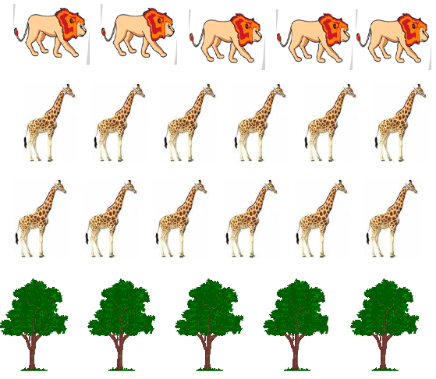
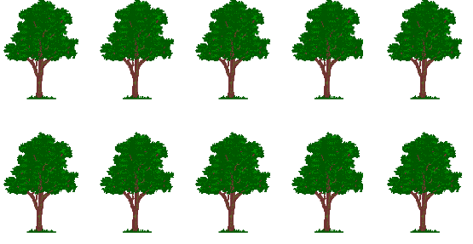

Name: _____________________________________ Date: ________________

Where is Carbon Dioxide Going?

Understanding carbon movement across entire ecosystems requires thinking about all of the types of organisms involved: plants, animals and decomposers. Please answer the following questions for your group’s organism, and then be prepared to share your answers with your classmates, and to listen to their explanations.

1. Does your organism have the ability to change carbon dioxide into organic forms of carbon?
____________________________________________________________________________________________________________________________________________________________________________________________________________________________________

If so, how much carbon could it remove and store over its lifetime (relative to other
organisms)? Where would it store the carbon?
____________________________________________________________________________________________________________________________________________________________________________________________________________________________________

2. Does your organism have the ability to change organic carbon back into carbon dioxide?
____________________________________________________________________________________________________________________________________________________________________________________________________________________________________

If so, when would it be sending carbon back to the atmosphere?
____________________________________________________________________________________________________________________________________________________________________________________________________________________________________
Look at the different reservoirs, or locations, where carbon is found. In this activity you will think about how carbon dioxide moves between these locations. Draw arrows going down showing which locations (including organisms) take in carbon dioxide. Draw arrows going up to show which locations (including organisms) give off carbon dioxide into the atmosphere.

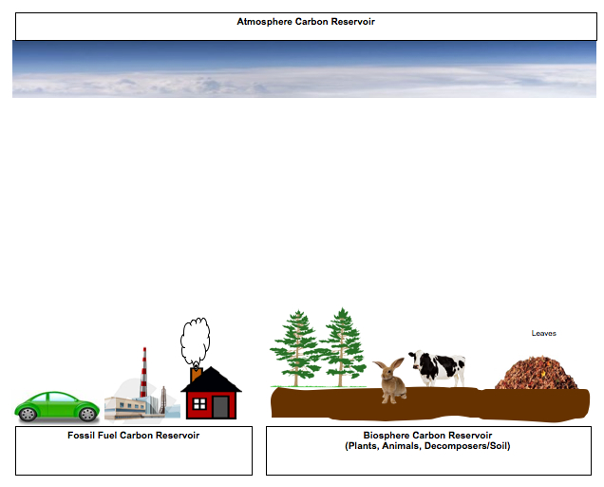
Questions

1. How are the plants different from other things in how they move carbon dioxide? ____________________________________________________________________________
____________________________________________________________________________________________________________________________________________________________________________________________________________________________________

2. If the arrows going in and out of the biosphere were equal, what do you think would happen if we then decided to cut down trees to make room for a new neighborhood? _______________
____________________________________________________________________________________________________________________________________________________________________________________________________________________________________

2. What would happen to the arrow from the fossil fuel reservoir if we choose to have more cars running on gasoline, and used more fossil fuels to power our homes? _____________________
____________________________________________________________________________________________________________________________________________________________________________________________________________________________________

Name: ________________________________________ Hour: __________

Plants and Global Carbon Cycling

Different types of plants can store carbon in their bodies in very different places and for very different lengths of time. Working with your group and the plant sample provided, fill out the following table for your sample. Then listen as other groups report on their sample and fill out the rest of the table accordingly.

Plant Type or Species | How much carbon stored each year? (Little, Moderate, Much) | How long will plant store carbon over its life?  (Short-term, Moderate, Long-term) | Where in the plant will most of the carbon be stored?  (Roots, Stem, Leaves, Other)
Annual Grass (Corn)

Perennial Grass (Turfgrass)

Herbaceous Perennial (Dandelion)

Woody Perennial (Maple Tree)

Terrestrial (Potted Plant)

Aquatic “Plants” (Sample of Pondwater)

1. As people choose how to use different parts of the landscape, which types of plants do you think they should encourage in order to store the most carbon? Which types will be the most help over the longest time? How did you decide?

2. What is the result for the global carbon cycle if large tracts of forest are cleared and planted with annual plants for farming? How about if abandoned farmland reverts to forest?

Back-up Photos for Plants and Global Carbon Cycling

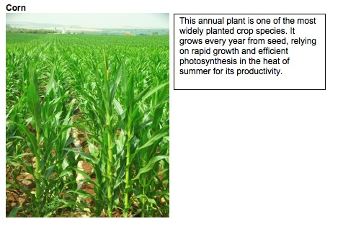
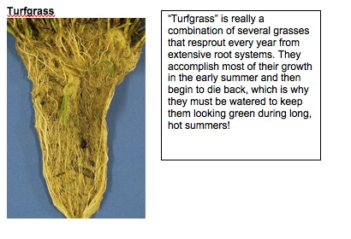
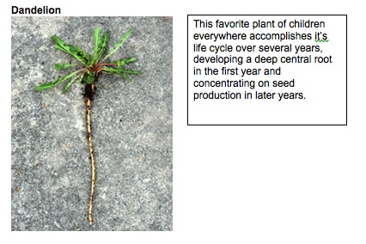
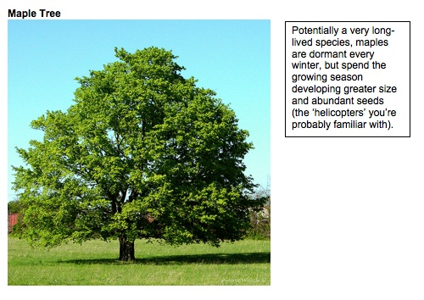
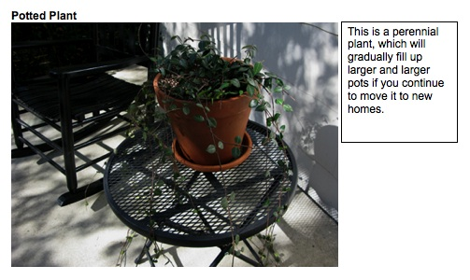
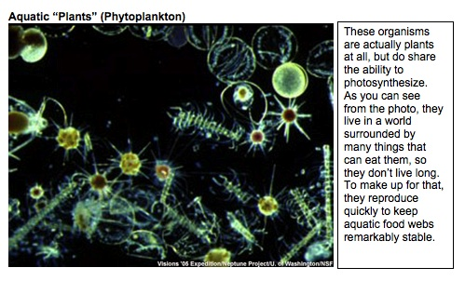
Name: ________________________________________ Hour: _________

Soil and Global Carbon Cycling

Carbon can remain in organic compounds in the soil long after an organism dies, but different compounds are broken down by decomposers at very different rates. The “woodier” materials of certain plants, in particular, can take decades or even hundreds of years to fully decompose. In contrast, ecosystems with few woody species tend to lose soil carbon more rapidly to the environment. Working with your group and the soil sample provided, fill out the following table for your sample. Then listen as other groups report on their sample and fill out the rest of the table accordingly.

Soil and Litter Type | How long will at least some of the carbon remain in soil?  (Short-term, Moderate, Long-term) | In what form will most of the carbon be present in the soil?  (Lignin, Cellulose, Starch) | How much carbon could be released to the atmosphere by plowing of this soil?  (Little, Some, Lots)
Forest
Grassland
Annual Cropfield

1. Is it important to consider the abundance of animals present above a soil when it comes to estimating soil carbon? Why or why not?

2. What kind of human management decisions are most likely to affect soil carbon levels? What would you recommend land managers do to increase or hold steady the amount of carbon stored in soils in this area?

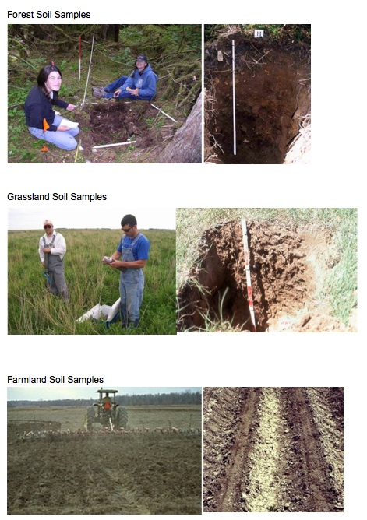
Name: _________________________________________ Date:__________

How Are Plants Different?

- What forms of matter and energy go in and out of plant cells during photosynthesis? Complete the diagram below.

- If someone claimed that a plant’s mass comes from CO₂ in the air, explain why you agree or disagree with that statement. __________________________________________________
___________________________________________________________________________________________________________________________________________________________________________________________________________________________
- Why are plants so important for other living things in terms of what they do with energy? _________________________________________________________________________
___________________________________________________________________________________________________________________________________________________________________________________________________________________________

Name: _____________________________________Period/Hour:__________

Decomposition Questions
- What types of matter and forms of energy go into and out of mold cells during decomposition of bread? Complete the Diagram below.

2. Think about how matter changes during decomposition. Would you agree or disagree that most dead plant and animal materials eventually become gases that go into the air? Support your ideas. ______________________________________________________
________________________________________________________________________________________________________________________________________________________________________________________________________________________________________________________________________________________

3. Decomposition is a process where decomposers use chemical energy found in dead plants and animals. What happens to the chemical energy in this process? How does it change? ______________________________________________________________
__________________________________________________________________________________________________________________________________________________________________________________________________________________
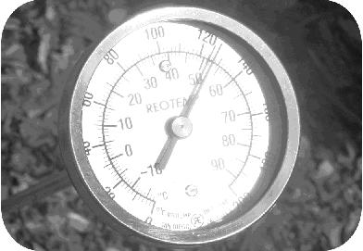
4. The picture shows a long stem thermometer inserted into a compost pile. The temperature reads 51°C (or 124°F). It is not uncommon for compost piles to reach this temperature, and they can even reach higher temperatures that exceed 60°C.
Think about how energy changes during cellular respiration. Explain why the temperature of compost is so high? _________________________________________
__________________________________________________________________________________________________________________________________________________________________________________________________________________

5. Why do you think decomposition is important in the global carbon cycle? ______________________________________________________________________
__________________________________________________________________________________________________________________________________________________________________________________________________________________

6. How do decomposers change the amount of organic carbon molecules and carbon dioxide molecules that we have in the carbon cycle? ____________________________
__________________________________________________________________________________________________________________________________________________________________________________________________________________
Name: _____________________________________ Date: ___________

Organisms Give Off Carbon Dioxide

When people breathe they give off carbon dioxide. This is true for other animals too. Even plants and decomposers give off carbon dioxide. But this is not all that happens inside animals.

1. Use the process tool to show how animals change matter and energy when they grow and move.

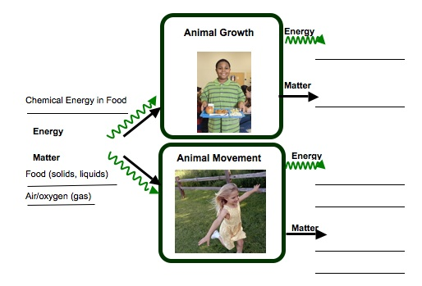

Plants are different from most other organisms because they take in carbon dioxide and make their own food (glucose) through the process of photosynthesis. They are some of the only organisms on Earth that can transform light energy into chemical energy. But plants do not make glucose for us! They make their food so they can store it (and grow) or use it to keep their cells working.

2. Use the process tool to show all the ways that plants change matter and energy.

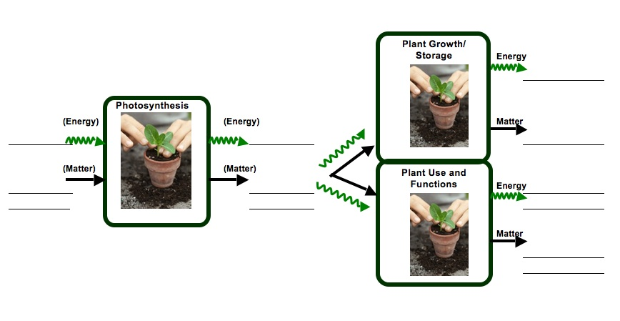
Name: ________________________________________ Hour: __________

Tracing the Carbon
Biofuels have been in the news recently as one way in which our country can use fewer fossil fuels, with benefits to both our economy and the world’s climate. Ethanol, in particular, has been identified as a liquid fuel that could replace large portions of our petroleum consumption. Currently most ethanol is made from corn grain, but large amounts of research are attempting to generate ethanol from other plant parts, including those composed largely of cellulose (i.e. wood-like parts of plants, including actual wood, corn stalks, etc.). Just like gas from oil, though, ethanol is combusted in the engines of vehicles to power their movement, and waste gases are still pushed out of their tailpipes. Then why would this fuel potentially be a good way to reduce global climate change? Working through the activity below should give you a better understanding of the differences between bio- and fossil fuels.
In the table below, describe the path of a carbon atom from CO₂ in the atmosphere to the fuel and back to the atmosphere as best as you can, by considering how the process mentioned would change the location of the carbon. Several boxes have been filled in for you. For other hints, you may want to think back to the “Energy Rich Materials” lesson you saw earlier in the year. For the “Time Frame” column, use your best guess; getting the exact answer is not as important as the relative lengths of time involved.

Step | Fossil Fuel (form of Carbon atoms) | Fossil Fuel (Time Frame in this step) | Biofuel (form of Carbon atoms) | Biofuel (Time Frame in this step)
 | CO₂ (gas) |  | CO₂ (gas)
Photosynthesis |  |  | Plant sugars
Transformation |  | Days to years
Transformation | Hydrocarbons |  | Ethanol
Combustion |  |  |  | Hours to days
Talk with a neighboring group to see how they described carbon movement in their fuel type. What is the key difference between a biofuel and a fossil fuel?

